Model Development Phase Template

|  |  |
| --- | --- |
| Date | 20 April 2025 |
| Student Name | Rohit Mahadik |
| Project Title | Uncovering The Hidden Treasures Of The Mushroom Kingdom: A Classification Analysis |
| Maximum Marks | 10 Marks |

Initial Model Training Code, Model Validation and Evaluation Report

Initial Model Training Code

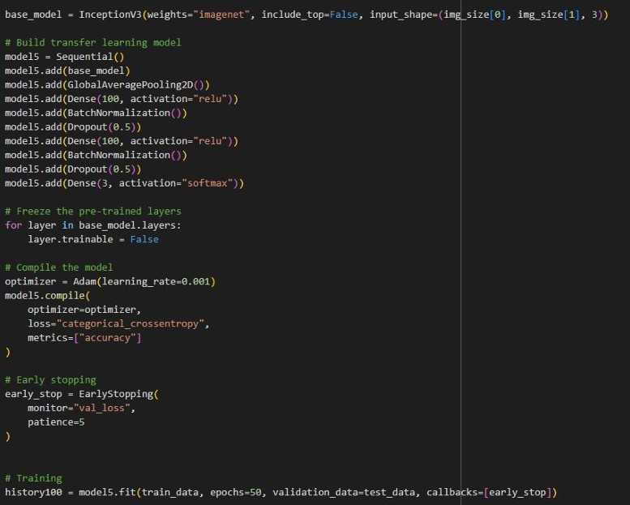

Model Validation and Evaluation Report

|  |  |  |
| --- | --- | --- |
| **Model** | **Summary** | **Training and Validation Performance Metrics** |
| **Model 1** (InceptionV3 + Custom Layers) | **Layer Summary:**   * InceptionV3 base model * GlobalAveragePooling2D * Dense(100, relu) * BatchNormalization * Dropout(0.5) * Dense(3, softmax)   **Total Parameters:**  2,311,305  **Trainable Parameters:**  2,304,505  **Non-trainable Parameters:** 6,800 | **Training Accuracy**: 83.42%  **Validation Accuracy**: 88.36%  Training converged well with slight overfitting mitigated by dropout and batch normalization. |